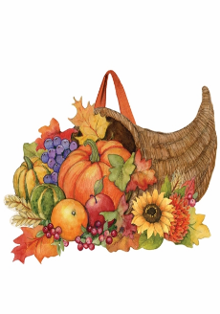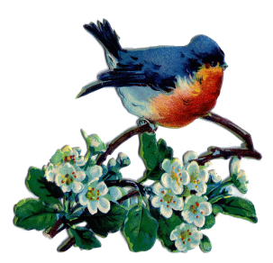***November Good News 2022***



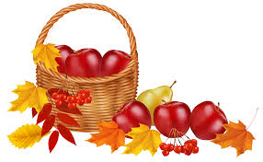**Our ministry vision for the Virginia Annual Conference is *“to be disciples of Jesus Christ who are lifelong learners, who influence others to serve.”***

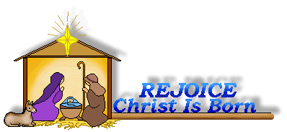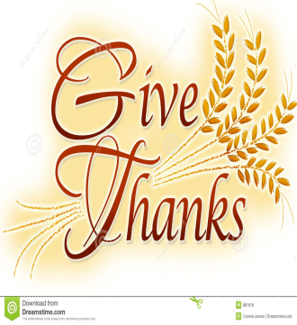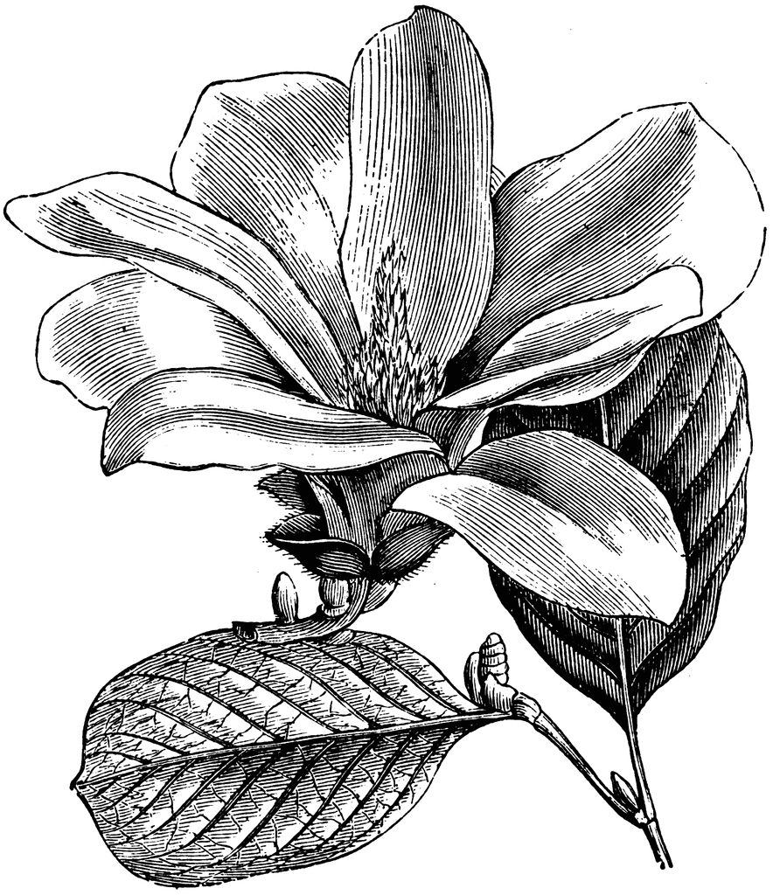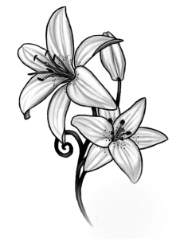

**From Pastor Adam**

*“Gratitude is Changing Lenses”*

*“Acknowledging the good that you already have in your life is the foundation for all abundance.”* ~ Eckhart Tolle

*"We often take for granted the very things that most deserve our gratitude."*

~ Cynthia Ozick

*“Gratitude looks to the Past and love to the Present; fear, avarice, lust, and ambition look*

*ahead.”* ~ C.S. Lewis

If anything can be said of human beings, it is that we are consistently forward-looking: we plan, we prepare, we anticipate. We are quite often spending our days preparing for what tomorrow might bring. Of course, this is a necessity, and a noble one at that. However, there also lies the risk that we postpone the full enjoyment of the present for some future we are

ever building. Sometimes we can postpone joy for some future date, saying to ourselves things like: “When I graduate from college, then my life will truly begin; when I get my first job, then my life will truly begin; when I get married and have a family, my life will truly begin; when I get this mortgage paid off, my life will truly begin; when I write the last college tuition check, then my life will truly begin; when I retire, my life will truly begin; when I have enough of everything, then my life will truly begin.”

There is something important about paying attention to the gifts of God we have received in days gone by, and the gifts of God we enjoy presently, that inspires gratitude in a way that we cannot experience when we are banking our whole existence on the future. In short, gratitude is matter of changing lenses, so that our focus can be redirected to the discovery and celebration of the good things we already have in the active present and the recent past. Gratitude is the most liberating and life-giving sentiment. As we look to Thanksgiving Day,

that great national day of gratitude, may we have our “lenses” focused on the treasures hiding right under our noses and every blessing along the way. And may we have the courage to let the “future be the future” as we leave those things to mercy and providence of God.

God bless you, my friends! Happy Thanksgiving!

Adam

**Choir News**

Check your Sunday’s bulletin for choir times and dates. Come and lend your voice. All are invited!!

~*Heather Wilson*, Director of Music

**Circle News**

* * * * * * * * * * * * * * * * * * *

The **Merry Marthas Circle** will meet on Wednesday, November 9, 2022, at 10:00 a.m. at church. We will have the UMW World Thank Offering program.

The **Wesleyan Group** will meet on Monday, November 14, 2022, at 7:00 p.m., at the home of Mary Walker (224 Legacy Oaks Circle, Lynchburg)

**NOTE:** On Saturday, December 3rd, will be the District UMW Advent Brunch at Rustburg UMC. Details to be announced later.

*Mission Memo*

In September we collected 68lbs of food and 13lbs of hygiene products for Park View Mission. They were thankful for our continued and faithful support which helps this mission to serve the community. Thank you for everyone who so graciously supports this outreach mission each month.

For November we will collect items to make side dishes for a holiday meal. Example: stuffing mix, cranberry sauce, yams, corn, green beans, etc. Also we will continue to collect deodorant and toothpaste.

~*Thank you the Mission Committee*

**Food Cart...**

 Items needed for the Food Cart for ***Park View Community Mission.***

For the Month of  **November**

We will collect any **side dish items for Thanksgiving.** Such as: stuffing, yams, corn, cranberry sauce, so forth. Still collecting canned meats and fruits. (Make sure all the cans have tab tops.)Also toothpaste and men/women deodorant**.**

(Make sure all the cans have tab tops

*Place donations in the grocery cart, located in the Commons*. **No “*baked goods*” of any kind.** *Place donations in the grocery cart, located in the Commons*

***Charge Conference***

**Mountain View District Palooza** (Annual Charge

Conference) **-- Saturday, November 5th at 9:30 am at Heritage UMC, 582 Leesville Rd., Lynchburg.**  
 (The District Office is asking for church buses or vans and offers of carpooling to transport church members to Heritage

UMC. Be in touch if you can help).

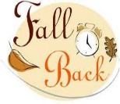

***Daylight Saving Time ends*** on Sunday, November 6th.

Remember to **Fall Back** one (1) hour on Saturday, November 5, 2022.

Churches for Urban Ministry

CITRUS SALE

For those who would like to order fruit, order forms are placed in the Commons. For information contact Eleanor Maxham. Deadline for orders is on **Sunday, November 13th**.

Mark you calendar:

On Saturday, November 26th, we will **decorate the sanctuary for Advent/Christmas** at 9:30 am. Contact Judy Robertson for more information.

**Chestnut Hill you are invited to:**

Homeschool’s Vendor Fair

Chestnut Hill UMC

Saturday, November 5, 2022

10:00 A.M. TO 3:00 P.M.

Crafts, refreshments, lots of fun

***Coming Up:***

**Christmas Offering**

We have set a goal of $6,000, with 10% going to Park View Community Mission, and 90% toward HVAC repair/replacement for social hall and educational building.

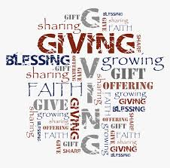



1 Ann Chakales

Jessica Robbins

2 Bob Clarke

5 Christopher

Palazzi

Donna Smith

6 Spencer Goolsby

8 Karsen Burgess

9 Sylvia Glass

Jacob Powell

10  Elizabeth

Ashworth

Charles Kitts

11 Casey Fish

12 Linda Mitchell

Charles Scott, Sr.

13 Pat Moore

14 Kathleen Baker

16 Kelli Adams

John Martin, Jr.

Maggie Musgrove

17 Christian Barber

Frank Stewart

19 Ed Gibson, Jr.

21 Derrick Tedder

24 Ann Ruhland

Lee Steward

25  D’Lynn Burgess

Elizabeth Candler

26 Ella Dunn

28 Tad LeFew, III

29 Mary Mattox

Kim Scott

30 Phillip Yost

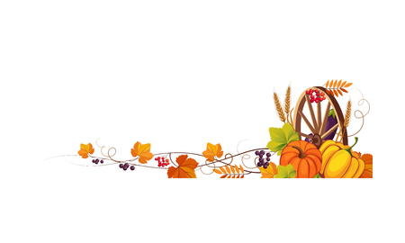

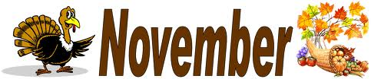

2022

|  |  |  |  |  |  |  |
| --- | --- | --- | --- | --- | --- | --- |
| ***Sunday*** | ***Monday*** | ***Tuesday*** | ***Wednesday*** | ***Thursday*** | ***Friday*** | ***Saturday*** |
| Free Thanksgiving Blessings Cliparts, Download Free Thanksgiving Blessings  Cliparts png images, Free ClipArts on Clipart Library | | **1** | **2** | **3** | **4**  10:00am Homeschool | **5**  9:30am Mountain View District Palooza @ Heritage UMC  10:00 amHomeschool  Vendor Fair |
| **6 *22nd Sunday after Pentecost***  **All Saints Sunday**  9:30am Sunday School  10:30am Worship | **7** | **8** | **9**  **Church Office Closed**  10:00am Merry Martha's | **10** | **11**  10:00am Homeschool | **12** |
| **13 *23rd Sunday after Pentecost***  9:30am Sunday School  10:30am Worship | **14**  7:00pm Wesleyan Group | **15** | **16** | **17** | **18**  10:00am Homeschool | **19** |
| **20 *Christ the King Sunday***  9:30am Sunday School  10:30am Worship | **21** | **22** | **23** | **24**  Church Office Closed | **25**  Church Office Closed | **26**  9:30am Decorating Advent/Christmas |
| **27 *1st Sunday of Advent***  9:30am Sunday School  10:30am Worship | **28** | **29** | **30** | Free Thankful Thanksgiving Cliparts, Download Free Thankful Thanksgiving  Cliparts png images, Free ClipArts on Clipart Library | | |

1 Pat Short

2 Nancy Lee

Emily V.

Fernandez

3 Michael McGlothlin

6 Kirsten Bell

Tim Crist

Dennis Tolley

7 Kenny Busic

Cheryl Powell

9 Owen Stinnette

Jeremey

VandeBogart

11 Landen Glass

12 Camden Mason

14 Wade Ware

16 Burton Brooks

Terry Palazzi

Anne-Elaine Tiller

17 Suzanne

Marshall

Blake Phillips

18 Sharon

Rickmon

19 Connie Yost

20 Erin Ecklund

21 Steven Kinzer

22 C.O. Bell

25 Frankie

Hardwick

28 Jacqueline Busic

Cheryl Thomas

29 Wes Robbins

Ricky Smith

31 Robert Baunach

**2022**

|  |  |
| --- | --- |
| **Those Who Serve~November**  **GREETERS:**  November 6 ~Dan Robertson  November 13 ~Betty Taylor  November 20 ~Ann Robbins  November 27 ~Judy Robertson    + + + + + + + + + + + + + + + + + + + + + + +  **GOOD NEWS** is published monthly for members and friends of Chestnut Hill United Methodist Church. Send articles to the church office by the 15th of the month. **(Subject to change.)**  + + + + + + + + + + + + + + + + + + + + + + +    **The Gratitude Gourd**        It is the first day of November,  Thanksgiving is only weeks away;  So it is with our gratitude  That this special gourd comes your way.  God tells us to be thankful,  For all the blessings He bestows.  We wanted to start a special tradition;  And the Gratitude arose.  This gourd is being given,  For all you do and who you are.  You may think you’re not so special.  But to us you’re a shining star! -copied    *“...let your light shine before others, so that they may see your good works and give glory to your Father who is in heaven.” ~ Matthew 5:16* | **Our Church Financial Picture**  Through the end of September 2022  General Operating Funds:  Needed to meet our 2022 Budget $ 194,759.00  Needed to meet our budget to date $ 146,069.00  Actual receipts to date $ 120,780.00  Shortage to meet budget to date $ 25,289.00  Actual expenditures to date $ 124,486.00  Overage to meet expenses to date $ - 3,706.00  Joy In Missions Funds:  Our Giving Goal for 2022 $ 11,600.00  Needed to meet our goal to date $ 8,700.00  Actual receipts to date $ 7,280.00  Special Offerings* (not budgeted):  Received to date $ 13,088.00  Dispersed to date $ 12,640.00  *Christmas, Easter, Annual Conference,  World Communion, etc.  **2022 Joy In Mission Donations**  To date, the following amounts have  been paid to the missions indicated.  Budget Spent  1. Missionary Covenant Relationship $1,000 $750  2. Interfaith Outreach $1,000 $750  3. Park View Mission, Food for  Families $3,000 $2,705  4. Society of St. Andrew $1,000 $500  1. Adult Care Center $ 500 $375  2. Blue Ridge Area Food Bank $ 1,000 $750  3. Camp Timothy $ 500 $500  4. Churches for Urban Ministry $ 500 $375  5. Daily Bread $ 500 $375  6. Free Clinic $ 500 $375  7. Good Neighbor $ 500 $0  8. Habitat for Humanity $ 500 $375  9. UMCOR-Non-Administrative $ 500 $0  10. Undesignated $ 600 $0  Thank You for Your Generosity |

**March 2022**



January 2022

**2022**

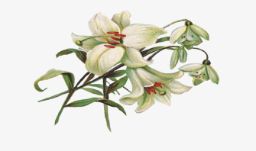

**April 2022**

**April 2022**

**March 2022**



*Chestnut Hill United*

*Methodist Church*

4660 Fort Avenue, Lynchburg, VA 24502

Phone Number: 434-239-8423: FAX: 434-239-7209

E-mail: [chestnuthillumc@comcast.net](mailto:chestnuthillumc@comcast.net)

On the web: www.chestnuthillumc.net

Church Office Hours

**Monday-Thursday~**9:00 am—3:30 pm

**Friday~**9:00 am-1:00 pm

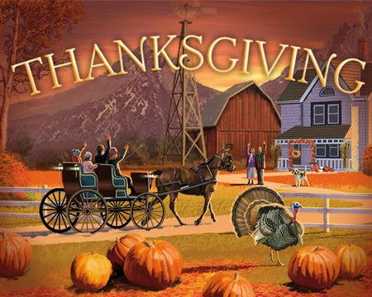

***DIRECTORY OF***

***CHESTNUT HILL UNITED METHODIST CHURCH***

|  |  |  |
| --- | --- | --- |
|  | Sharma Lewis | Richmond Area Resident Bishop |
|  | Denise Bates | Mountain View District Superintendent |
|  | Adam White | Minister |
|  | Erin Long | Associate Minister |
|  | Monica C. Campbell | Administrative Assistant |
|  | Heather Wilson | Director of Music Ministry |
|  | Judy Martin | Bookkeeper |
|  | Judy Robertson | Lay Leader |